

## A Minor Project Report on

**BOREWELL WATER OVERFLOW DETECTION AND PREVENTION SYSTEM**

## **Submitted by**

**NALIN KUMAR S P (927622BEE073)**

## SANJAAI U N (927622BEE094)

## SHARMITHA S P (927622BEE106)



**DEPARTMENT OF ELECTRICAL AND ELECTRONICS ENGINEERING M.KUMARASAMY COLLEGE OF ENGINEERING**

(An Autonomous Institution Affiliated to Anna University, Chennai) THALAVAPALAYAM, KARUR-639113.

## MAY 2025

M.KUMARASAMY COLLEGE Of ENGINEERING

(Autonomous Institution, Affiliated to Anna University, Chennai)

# BONAFIDE CERTIFICATE

Certified that this Report titled **“BOREWELL WATER OVERFLOW DETECTION AND PREVENTION SYSTEM”** is the Bonafide work of **NALIN KUMAR S P (927622BEE073), SANJAAI U N (927622BEE094), SHARMITHA S P (927622BEE106)** who carried out the work during the academic year (2024-2025) under my supervision. Certified further that to the best of my knowledge the work reported herein does not form part of any other project report.

**SIGNATURE SIGNATURE**

**SUPERVISOR HEAD OF THE DEPARTMENT**

Mr.N.Selvam M.E., Dr.J.Uma M.E., Ph.D.,

Assistant Professor Professor & Head

Department of Electrical and Electronics Engineering

M.Kumarasamy College of

Engineering, Karur.

Department of Electrical and Electronics Engineering

M.Kumarasamy College of

Engineering, Karur.

Submitted for Minor Project IV (18EEP302L) viva-voce Examination held at M Kumarasamy College of Engineering, Karur-639113 on ………………..

## DECLARATION

We affirm that the Minor Project IV report titled **“BOREWELL WATER OVERFLOW DETECTION AND PREVENTION SYSTEM”** being submitted in partial fulfillment for the award of **Bachelor of Engineering in Electrical and Electronics Engineering** is the original work carried out by us.

|  |  |  |
| --- | --- | --- |
| **REG.NO** | **STUDENT NAME** | **SIGNATURE** |
| **927622BEE073** | **NALIN KUMAR S P** | **-----------------------** |
| **927622BEE094** | **SANJAAI U N** | **-----------------------** |
| **927622BEE106** | **SHARMITHA S P** | **-----------------------** |

### VISION AND MISSION OF THE INSTITUTION

**VISION**

* To emerge as a leader among the top institutions in the field of technical education

### MISSION

* Produce smart technocrats with empirical knowledge who can surmount the global Challenges.
* Create a diverse, fully engaged, learner - centric campus environment to provide Quality education to the students.
* Maintain mutually beneficial partnerships with our alumni, industry and Professional associations.

### DEPARTMENT OF ELECTRICAL AND ELECTRONICS ENGINEERING

**VISION**

* To produce smart and dynamic professionals with profound theoretical and practical knowledge comparable with the best in the field.

### MISSION

* Produce hi-tech professionals in the field of Electrical and Electronics Engineering by inculcating core knowledge.
* Produce highly competent professionals with thrust on research.
* Provide personalized training to the students for enriching their skills.

### PROGRAMME EDUCATIONAL OBJECTIVES(PEOs)

* **PEO1:** Graduates will have flourishing career in the core areas of Electrical Engineering and allied disciplines.
* **PEO2:** Graduates will pursue higher studies and succeed in academic/research careers.
* **PEO3:** Graduates will be a successful entrepreneur in creating jobs related to Electrical and Electronics Engineering /allied disciplines.
* **PEO4:** Graduates will practice ethics and have habit of continuous learning for their success in the chosen career.

**PROGRAMME OUTCOMES(POs)**

After the successful completion of the B.E. Electrical and Electronics Engineering degree program, the students will be able to:

**PO1: Engineering Knowledge:** Apply the knowledge of mathematics, science, engineering fundamentals, and an engineering specialization to the solution of complex engineering problems.

**PO2: Problem Analysis:** Identify, formulate, review research literature, and analyze complex engineering problems reaching substantiated conclusions using first principles of mathematics, natural sciences, and engineering sciences.

**PO3: Design/Development of solutions:** Design solutions for Complex engineering problems and design system components or processes that meet the specified needs with appropriate consideration for the public health and safety, and the cultural, societal, and environmental considerations.

**PO4: Conduct Investigations of complex problems:** Use research-based knowledge and research methods including design of experiments, analysis and interpretation of data, and synthesis of the information to provide valid conclusions.

**PO5: Modern Tool Usage:** Create, select, and apply appropriate techniques, resources, and modern engineering and IT tools including prediction and modeling to complex engineering activities with an understanding of the limitations.

**PO6: The Engineer and Society:** Apply reasoning in formed by the contextual knowledge to assess societal, health, safety, legal and cultural issues and the consequent responsibilities relevant to professional engineering practice.

**PO7: Environment and Sustainability:** Understand the impact of the professional engineering solutions in societal and environmental contexts, and demonstrate the knowledge of, and need for sustainable development.

**PO8: Ethics:** Apply ethical principles and commit to professional ethics and responsibilities and norms of the engineering practice.

**PO9: Individual and Teamwork:** Function effectively as an individual, and as a member or leader in diverse teams, and in multi-disciplinary settings.

**PO10: Communication:** Communicate effectively on complex engineering activities with the engineering community and with society at large, such as, being able to comprehend and write effective reports and design documentation, make effective presentations, and give and receive clear instructions.

**PO11: Project Management and Finance:** Demonstrate knowledge and understanding of the engineering and management principles and apply these to one’s own work, as a member and leader in a team, to manage projects and in multi-disciplinary environments.

**PO12: Life-long learning:** Recognize the need for and have the preparation and ability to engage in independent and life-long learning in the broadest context of technological change.

### PROGRAM SPECIFIC OUTCOMES(PSOs)

The following are the Program Specific Outcomes of Engineering Students:

* **PSO1:** Apply the basic concepts of mathematics and science to analyses and design circuits, controls, Electrical machines and drives to solve complex problems.
* **PSO2:** Apply relevant models, resources and emerging tools and techniques to provide solutions to power and energy related issues & challenges.
* **PSO3:** Design, Develop and implement methods and concepts to facilitate solutions for electrical and electronics engineering related real-world problems.

|  |  |
| --- | --- |
| **Abstract (Key Words)** | **Mapping of POs and PSOs** |
| Arduino Uno, Water sensor, Pressure sensor, Relay, water Pump, GSM Module. | PO1, PO2, PO3, PO4, PO5, PO6, PO7, PO8, PO9,PO10,PO11, PSO1, PSO2, PSO3. |

## [ACKNOWLEDGEMENT](https://www.google.com/search?rlz=1C1CHBD_enIN820IN820&q=ACKNOWLEDGEMENT&spell=1&sa=X&ved=0ahUKEwj99az1_ZXhAhVN63MBHRVODE4QkeECCCkoAA&cshid=1553265789884876)

Our sincere thanks to **Thiru.M.Kumarasamy Founder, and Dr.K.Ramakrishnan B.E, Chairman** of **M.Kumarasamy College of Engineering** for providing extra ordinary infrastructure, which helped us to complete the Minor project in time.

It is a great privilege for us to express our gratitude to our esteemed **Principal Dr.B.S.Murugan., M.Tech., Ph.D.,** for providing us right ambiance for carrying out the project work.

We would like to thank our **Head of the Department Dr.J.Uma.,M.E., Ph.D., Department of Electrical and Electronics Engineering,** for her unwavering moral support throughout the evolution of the project.

We would like to express my deep gratitude to our Minor Project Guide **Mr.N.Selvam**.,**M.E., Assistant Professor, Department of Electrical and Electronics Engineering,** for his constant encouragement, kind co-operation, valuable suggestions and support rendered in making our project a success.

We offer our wholehearted thanks to our Minor project coordinator **Dr.T.Hariharansudhan.,M.E.,Ph.D., Assistant Professor, Department of Electrical and Electronics Engineering,** for his constant encouragement, kind co-operation and valuable suggestions for making our project a success.

We are glad to thank all the **Faculty Members** of **Department of Electrical and Electronics Engineering** for extending a warm helping hand and valuable suggestions throughout the project.

Words are boundless to thank **Our Parents and Friends** for their constant encouragement to complete this Minor project successfully.

|  |  |  |
| --- | --- | --- |
| **CHAPTER NO** | **CONTENTS** | **PAGE NO** |
|  | VISION AND MISSION OF THE INSTITUTION | iv |
|  | **VISION AND MISSION OF THE DEPARTMENT** | iv |
|  | **PROGRAM OUTCOMES** | iv |
|  | **PROGRAM SPECIFIC OUTCOMES** | v |
|  | **LIST OF FIGURES** | x |
|  | **LIST OF ABBREVIATIONS** | xii |
|  | **ABSTRACT** | xiii |
| 1 | **INDRODUCTION** | 1 |
| 2 | **LITRATURE REVIEW**  2.1 **Borewell Monitoring using Microcontroller-Based Systems** **2.2 GSM Module for Remote Water Level Alerts 2.3 Automated Overflow Prevention in Borewell Systems****2.4 Enhancing Borewell Systems with IoT and GPS Integration** | 2  2  3  3 |
| 3 | **PROPOSED METHODOLOGY**  3.1 Block diagram  3.2 Description  3.3 Cost estimation | 4  4  5 |
| 4 | **HARDWARE DESCRIPTION**  4.1 Arduino UNO 4.2 **Pressure Sensor (HX710B)** | 6  6 |

**TABLE OF CONTENTS**

|  |  |  |
| --- | --- | --- |
|  | 4.3 **Water Level Sensor** 4.4 Relay module  4.5 **DC Water Pump**  4.6 **GSM Module (SIM900A)** | 7  7  8  8 |
| 5 | **RESULT AND DISCUSSIONS**  5.1 Hardware kit  5.2 Description  5..3 **Borewell is under high water level condition**  5.4 **Borewell is under overflow condition** | 9  9  10  11 |
| 6 | **CONCLUSION AND FUTURE SCOPE** | 12 |
|  | **REFERENCES** | 14 |

**LIST OF FIGURES**

|  |  |  |
| --- | --- | --- |
| **FIGURE NO** | **TITLE** | **PAGE NO** |
| 3.1 | Block diagram of borewell water overflow detection and prevention system | 4 |
| 4.1 | Arduino Uno | 6 |
| 4.2 | **Pressure Sensor (HX710B)** | 6 |
| 4.3 | **Water Level Sensor** | 7 |
| 4.4 | Relay module | 7 |
| 4.5 | **DC Water Pump (5V)** | 8 |
| 4.6 | **GSM Module (SIM900A)** | 8 |
| 5.1 | Project kit of borewell water overflow detection and prevention system | 9 |
| 5.2 | SMS alert at high water level in borewell | 10 |
| 5.3 | SMS alert at **orewell is under overflow condition** | 11 |

**LIST OF TABALE**

|  |  |  |
| --- | --- | --- |
| **TABLE NO** | **TITLE** | **PAGE NO** |
| 3.1 | Cost estimation | 5 |

**LIST OF ABBREVIATION**

|  |  |  |
| --- | --- | --- |
| **S.NO** | **ABBREVIATION** | **EXPANSION** |
| 1 | SIM | Subscriber Identify Module |
| 2 | IoT | Internet of Things |
| 3 | ADC | Analog-to-Digital Converter |
| 4 | DC | Direct Current |
| 5 | GSM | Global System for Mobile Communication |
| 6 | SMS | Short Message Service |
| 7 | Wi-Fi | Wireless Fidelity |
| 8 | GPS | Global Positioning System |

**ABSTRACT**

The objective of this project is to design and implement an ****Arduino-based Borewell Water Overflow Detection and Prevention System**** that ensures efficient and automated monitoring of borewell water levels. Water wastage due to overflow is a common issue in many rural and urban areas, especially when borewells are left unattended. To address this, the proposed system uses **three water level sensors** placed at different depths to monitor varying levels of water inside the borewell and an **HX710B pressure sensor** to track internal borewell pressure for additional monitoring.All sensor data is fed into an **Arduino Uno**, which acts as the central control unit. The Arduino processes the input data in real-time and makes decisions based on pre-defined conditions. Upon detecting high water levels or overflow risk, the system sends **SMS alerts** to the user through a **SIM800/900 GSM module**, providing timely notifications and enabling remote awareness. A **manual switch** is also integrated into the system, allowing users to activate a **relay-controlled drain valve**, which opens to discharge excess water and prevent spillage.This project is fully automated, cost-effective, and scalable, requiring minimal maintenance. It is particularly useful for agricultural and residential areas where borewell water management is crucial. Future enhancements can include **automated valve control, solar-powered operation, IoT integration**, and **GPS-based location tracking** to send SMS alerts with exact coordinates in real-time.

**Keywords:**

Arduino Uno, Borewell monitoring, Water level sensor, Pressure sensor, GSM module, Relay module, Overflow prevention, Remote alert system.

**CHAPTER 1**

**INDRODUCTION**

Water management in borewell systems is becoming increasingly important due to rising demand, resource scarcity, and wastage caused by overflow. Borewells, widely used in both rural and urban areas for agricultural and domestic water supply, are often left unattended during water extraction, leading to overflow and unnecessary water loss. Manual monitoring of water levels is not only labor-intensive but also unreliable in remote areas. This project aims to address these challenges by developing an **automated, Arduino-based Borewell Water Overflow Detection and Prevention System** that is both **cost-effective** and easy to implement.The system is designed to continuously monitor water levels inside the borewell using **three water level sensors** strategically placed at different depths. An additional **HX710B pressure sensor** is used to observe borewell pressure variations, which can help in evaluating the presence and flow of water. The core of the system is an **Arduino Uno**, which receives analog/digital input signals from these sensors and processes them in real time. When the water level reaches a critical height, indicating a potential overflow, the system sends **SMS alerts** to the user via a **GSM module (SIM800/900)**, ensuring remote notification and awareness.This system is designed with affordability and simplicity in mind, making it suitable for **small-scale farms, local water supply units, and individual borewell owners**. Its flexibility allows for easy customization and future upgrades, such as **automatic valve control, solar-powered operation, GPS tracking for location-based alerts, and integration with IoT platforms** for real-time remote monitoring and data logging.By providing a smart and reliable solution for borewell overflow management, this project contributes to **water conservation efforts**, enhances operational safety, and reduces the risk of structural damage caused by overflow. It lays a strong foundation for developing more advanced and connected water monitoring systems in the future.

**CHAPTER 2**

**LITERATURE REVIEW**

### ****2.1 Borewell Monitoring using Microcontroller-Based Systems****

### ****Source:**** Sharma, K., & Meena, R. (2017). **“Microcontroller-Based Borewell Monitoring for Water Management”**, International Journal of Embedded Systems and Applications. ****Inference:**** This study discusses the limitations of manual borewell monitoring and the advantages of microcontroller-based systems in ensuring efficient water management. Traditional monitoring methods fail to provide timely alerts during overflow, often leading to water wastage. The study highlights how using microcontrollers like Arduino enables real-time monitoring through sensor integration, allowing for automatic alert generation. The system's flexibility, low cost, and ease of implementation make it especially suitable for borewell management in rural and agricultural areas.

### ****2.2 Use of GSM Module for Remote Water Level Alerts****

### ****Source:**** Kumar, R., & Verma, A. (2018). **“GSM-Based Water Level Monitoring and Alert System”**, International Journal of Advanced Research in Electronics and Communication Engineering. ****Inference:**** This paper demonstrates the integration of GSM technology with microcontroller platforms to remotely alert users when water levels reach critical points. By sending SMS alerts to users, the system enhances remote awareness and reduces dependency on manual supervision. This is particularly effective for borewell systems located in remote or unattended areas. The implementation proved cost-effective and reliable for real-time applications.

### ****2.3 Automated Overflow Prevention in Borewell Systems****

### ****Source:**** Nair, S., & Bhat, D. (2019). **“Design of an Automatic Borewell Overflow Prevention System Using Sensors”**, Journal of Applied Engineering Research. ****Inference:**** The authors propose a sensor-based system to prevent borewell overflow by detecting water levels at various depths. When a high-level threshold is reached, the system can activate a valve or motor to stop water flow. The use of water level sensors combined with a relay mechanism forms the core idea of automation in borewell overflow control. This study supports the viability of using a microcontroller to manage input signals and operate relays for mechanical control.

### ****2.4 Enhancing Borewell Systems with IoT and GPS Integration****

### ****Source:**** Reddy, M., & Das, P. (2021). **“IoT-Based Smart Borewell Monitoring System with GPS Integration”**, IEEE International Conference on Smart Systems. ****Inference:**** This paper explores how IoT platforms and GPS modules can be integrated into borewell monitoring systems for real-time tracking and alerting. GPS helps in tagging the physical location of borewells in large fields or distributed networks, and IoT enables cloud-based data logging and alert systems. Although more complex, this approach adds smart capabilities for water conservation and monitoring. The study indicates a growing trend towards combining Arduino with IoT and GPS for smarter water management.

**CHAPTER 3**

**PROPOSED METHODOLOGY**

**3.1 Block diagram**

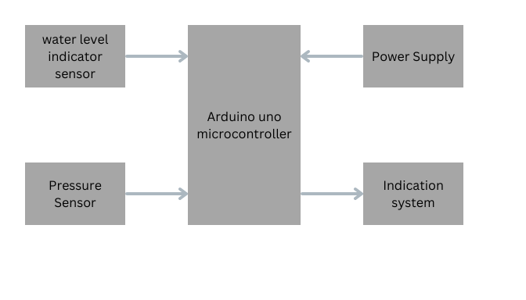

**Fig 3.1** Block diagram of borewell water overflow detection and prevention system

**3.2 Description**

The borewell overflow detection and prevention system uses water level sensors to detect the presence of water at different depths in the borewell. These sensors act as switches and give digital HIGH or LOW outputs based on whether water is detected at that particular level. Three water level sensors are placed at different heights to monitor the water level in real-time.

Each sensor is connected to a digital input pin of the Arduino Uno. When water is detected by a sensor, the Arduino receives a HIGH signal from that pin. The system logic checks the status of all three sensors continuously. If the second sensor detects water, it indicates that the water level is high, and the Arduino triggers the GSM module to send an SMS alert to the user stating **“Borewell has high water level.”** If the third sensor detects water, it signifies an overflow condition, and the Arduino immediately sends an alert SMS saying **“Borewell is under overflow condition.”**

Additionally, a pressure sensor (HX710B) is used to monitor pressure data, and its readings are displayed on the Serial Monitor for real-time observation. A switch is connected to pin A3 to control the drain valve. If the switch is turned ON (HIGH), the Arduino activates a relay connected to the valve and simultaneously sends another SMS: **“Drain valve is open in the borewell.”**

The GSM module (SIM800/900) is used for communication, sending SMS alerts to a pre-configured mobile number. The GPS module (NEO-6M) is used to retrieve the real-time location of the borewell, and this location is included in the SMS during an overflow alert. This feature ensures the owner or monitoring authority knows exactly where the problem is occurring.

The entire system works automatically without human intervention. It is highly suitable for remote borewells, especially in agricultural fields. The design is low-cost and reliable, making it a perfect fit for rural and small-scale applications where water conservation and quick action against overflow are critical.

**3.3 Cost estimation of the project**

**Table 3.1 Cost estimation**

|  |  |  |  |
| --- | --- | --- | --- |
| **S.NO** | **COMPONENT** | **QUANTITY** | **COST** |
| 01 | Arduino UNO | 1 | 650 |
| 02 | Water Level sensor | 3 | 150 |
| 03 | Pressure sensor | 1 | 100 |
| 04 | Water Pump | 1 | 100 |
| 05 | GSM Module | 1 | 750 |
| 06 | Relay | 1 | 50 |
| 07 | Other |  | 700 |
|  |  | **Total** | 2500 |

**CHAPTER 4**

**HARDWARE DESCRIPTION**

**4.1 Arduino Uno**

Arduino uno board has 6 ADC input ports. Among those any one or all of them can be used as inputs for Analog voltage. The Arduino Uno ADCis of 10-bit resolution (so the integer values from (0-(2^10) 1023)). This means that it will map input voltages between 0 and 5 volts into integer values between 0 and 1023. So, for every (5/1024= 4.9mV) per unit. The UNO ADC channels have a default reference value of 5V. This means we can give a maximum input voltage of 5V for ADC conversion at any input channel. Since some sensors provide voltages from 0-2.5V, with a 5V reference we get lesser accuracy, so we have a instruction that enables us to change this reference value.

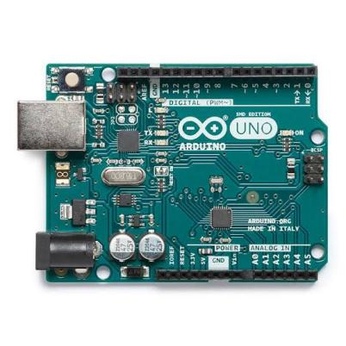

**Fig 4.1 Arduino Uno**

### **4.2 **Pressure Sensor (HX710B)****

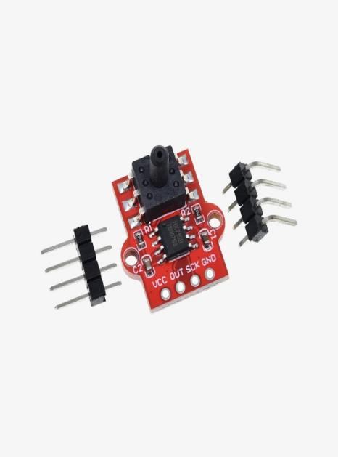The HX710B is a high-precision 24-bit ADC module used to read pressure from sensors like pressure transducers. It provides a digital output and communicates with the Arduino via I2C or SPI. It operates at 2.6V to 5.5V and is compatible with Arduino Uno. In this project, it helps monitor borewell pressure levels to detect overflow or abnormal pressure changes.It ensures real-time monitoring and provides accurate data even with small pressure changes. The compact design makes it ideal for embedded and low-power applications.

**Fig 4.2 **Pressure Sensor (HX710B)****

### **4.3 **Water Level Sensor****

The water level sensor is used to detect the presence and level of water in the borewell. It typically operates on 3.3V to 5V and provides an analog or digital signal to the Arduino depending on the water contact. The sensor consists of exposed conductive lines that change resistance when water touches them.In this project, multiple sensors are placed at different depths to monitor water levels and detect overflow conditions. It is low-cost, easy to use, and ideal for real-time water level detection in automation systems.

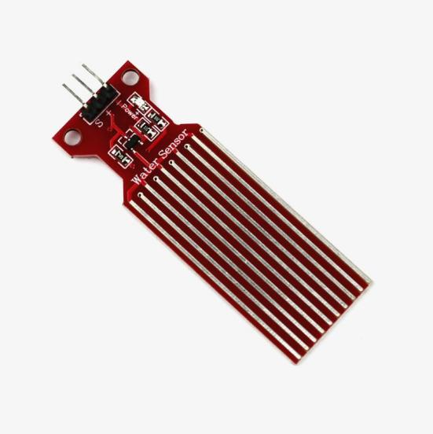

**Fig 4.3 **Water Level Sensor****

**4.4 Relay module**

The relay module acts as an electrical switch that is controlled by the Arduino. When the system detects an overload, the Arduino sends a signal to the relay module, which interrupts the connection between the transformer and the grid. The relay used in this project operates at 5V and is capable of controlling high-voltage AC devices like transformers. This module allows the system to physically isolate the transformer from the power grid, preventing damage during overloads.

**Fig 4.4 Relay module**

### **4.5 **DC Water Pump (5V)****

The 5V DC water pump is a compact, submersible pump commonly used in small-scale water automation projects. It operates on a 3V–6V DC power supply and can lift water up to 40–110 cm, depending on voltage. It typically consumes around 130–200 mA of current. In this project, it can be used to automatically drain excess water when overflow is detected in the borewell. The pump is lightweight, energy-efficient, and easy to interface with the Arduino using a transistor or relay.

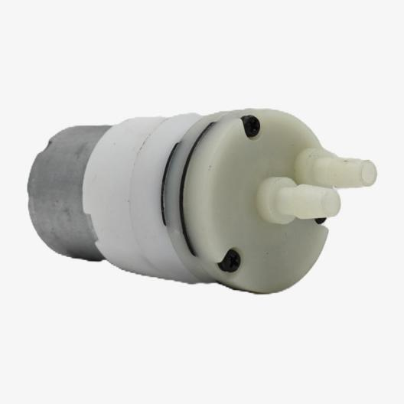

**Fig 4.5 **DC Water Pump****

### **4.6 **GSM Module (SIM900A)****

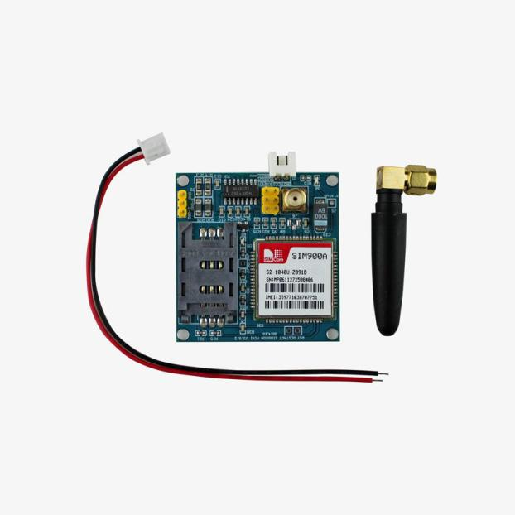The GSM module (SIM800 or SIM900) is used to send SMS alerts via a mobile network. It operates on a 3.7V–4.2V power supply and communicates with the Arduino through serial (UART) using AT commands.It supports quad-band frequencies (850/900/1800/1900 MHz), making it compatible with most global GSM networks. A standard SIM card is inserted into the module to enable communication with the mobile network provider.In this project, the GSM module sends real-time SMS notifications when water overflows or critical events are detected in the borewell system. It ensures timely alerts to users even in remote areas without internet.

**Fig 4.6 **GSM Module (SIM900A)****

**CHAPTER 5  
RESULTS AND DISCUSSION**

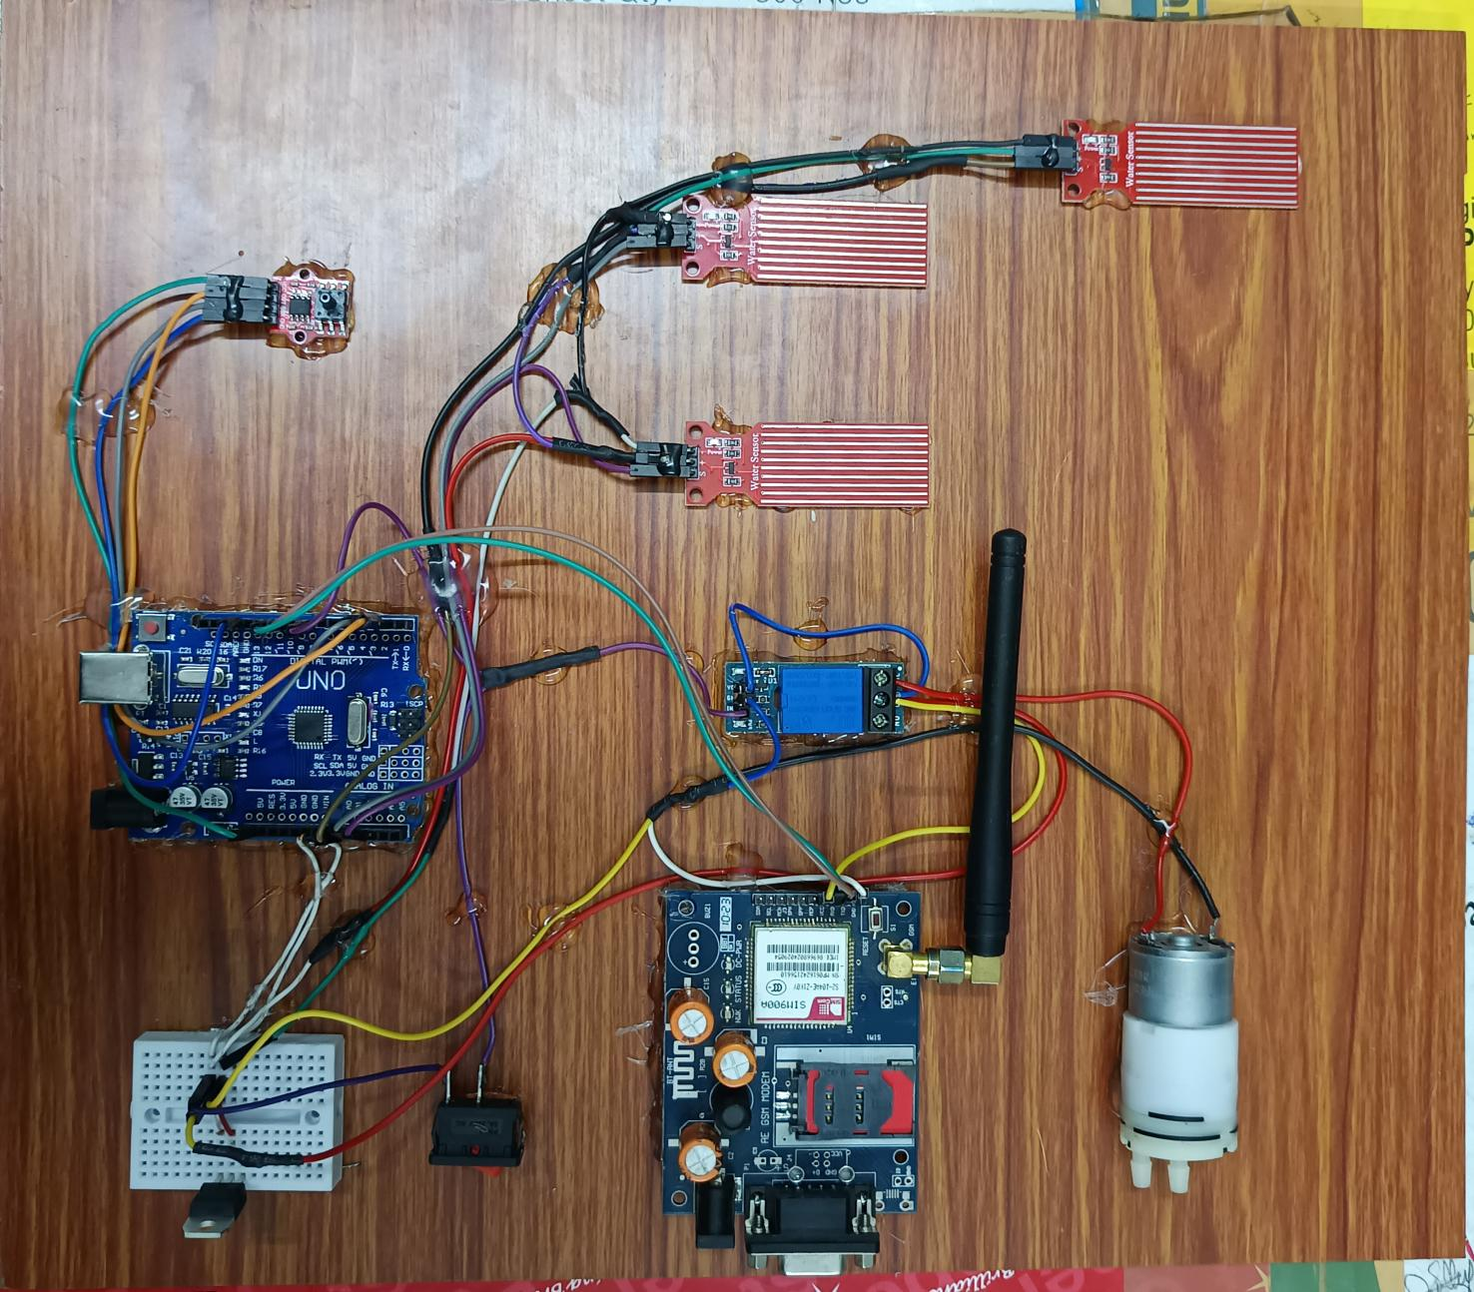**5.1 Hardware kit**

**Fig 5.1 Project kit of borewell water overflow detection and prevention system**

**5.2 Description**

The Borewell Overflow Detection and Prevention System is developed to monitor and control the water levels in borewells, especially in agricultural and remote areas. This system uses water level sensors, a pressure sensor, a GSM module, and a drain valve mechanism controlled by an Arduino Uno. Three digital water level sensors are placed at different depths in the borewell. These sensors act as switches, giving a HIGH signal when

water is detected. Each sensor is connected to a digital pin of the Arduino Uno, which continuously checks their status. When the **second sensor** detects water, it indicates that the water level is high. The Arduino then sends an SMS alert via the **GSM module (SIM800/900)** to a pre-configured mobile number: **“Borewell has high water level.”** If the **third sensor** is also triggered, it means the water has reached an overflow condition. The Arduino immediately sends another SMS: **“Borewell is under overflow condition.”** A **pressure sensor (HX710B)** is used to measure the pressure within the borewell. These readings are displayed on the Arduino Serial Monitor, helping users monitor pressure changes in real-time. To physically prevent overflow, a **drain valve** is included in the system. A switch connected to pin A3 of the Arduino is used to control the valve. When the switch is turned ON (HIGH), the Arduino activates a **relay** to open the valve and sends an SMS: **“Drain valve is open in the borewell.”**

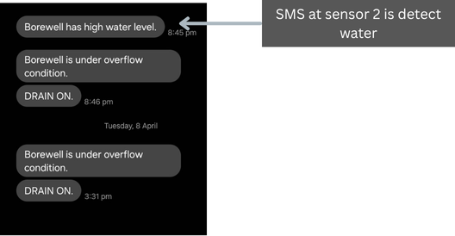**5.3 Borewell Under High Water Level Condition**

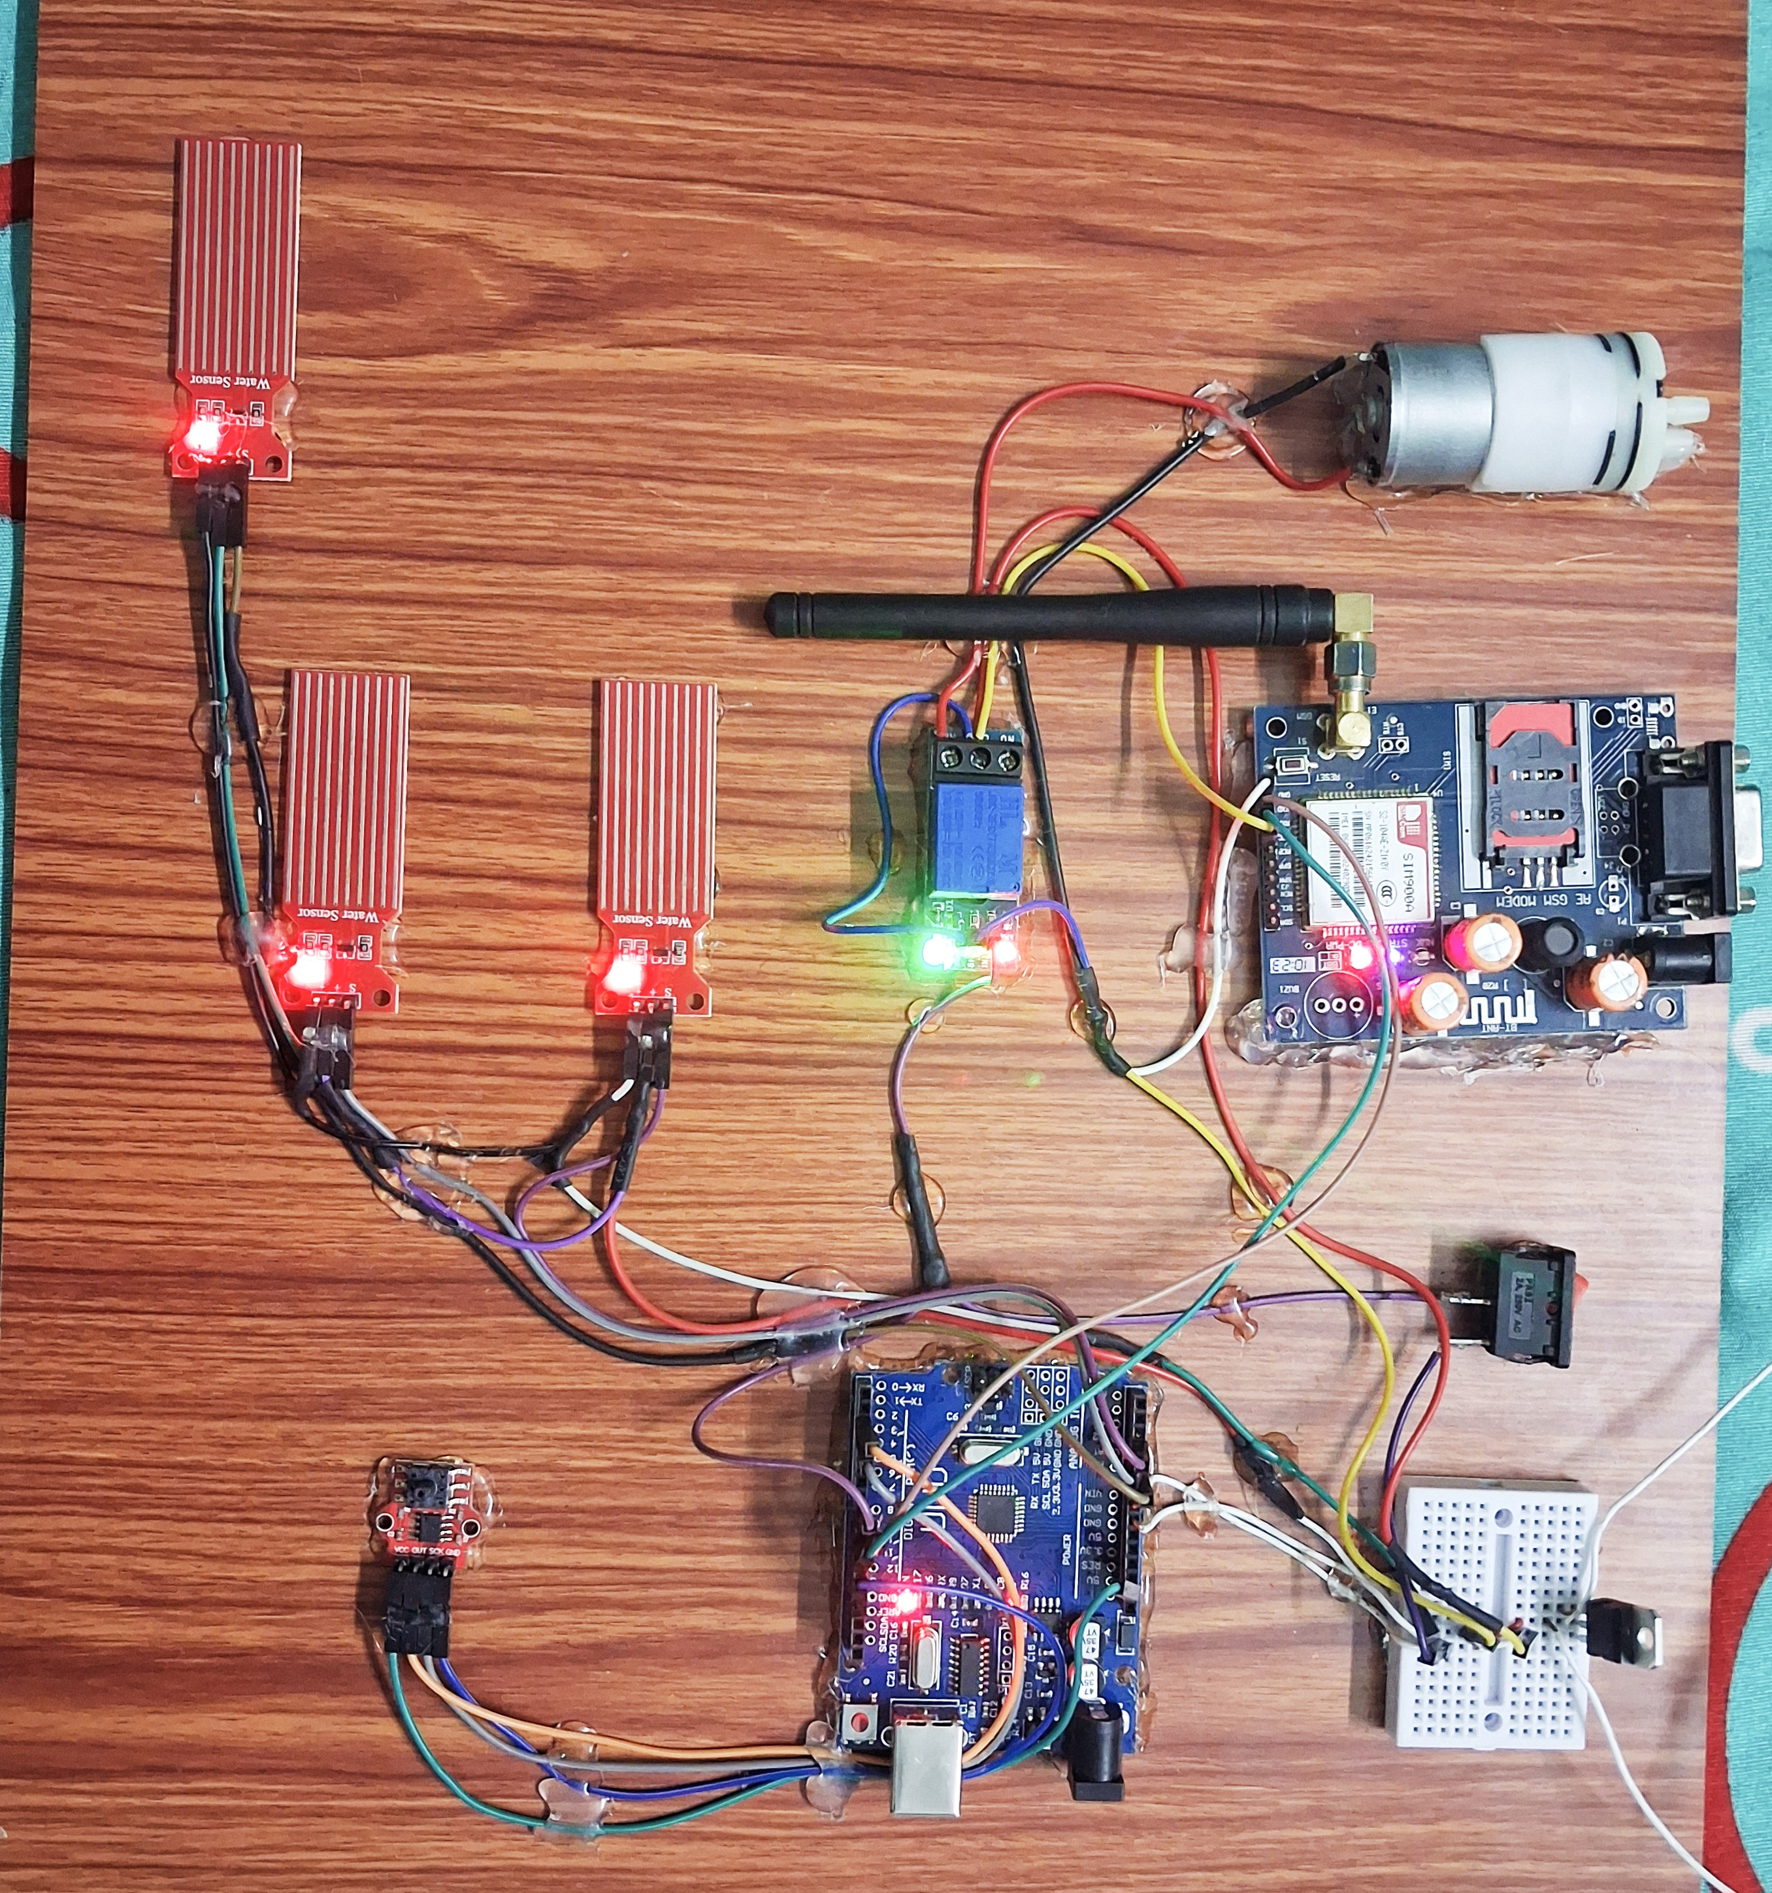

**Fig 5.2 SMS alert at high water level in borewell**

When water in the borewell rises and touches the **second water level sensor**, the sensor sends a **HIGH signal** to the **Arduino Uno**. This tells the Arduino that the water level is high but not yet overflowing. The Arduino immediately uses the **GSM module** (SIM800/900) to send a text message (SMS) to the user’s mobile number. The message says: **“Borewell has high water level.”** This alert helps the user know that the water level is rising and action may be needed soon to avoid overflow. The system works automatically without manual checking.

**5.4 **Borewell is under overflow condition****

**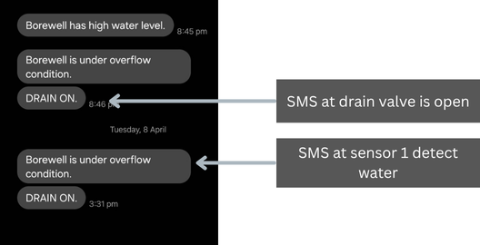******

**Fig 5.3SMS alert at **orewell is under overflow condition****

When water reaches the **third water level sensor**, it means the borewell is about to overflow. The sensor sends a **HIGH signal** to the **Arduino Uno**, which then sends an SMS alert using the **GSM module** saying: **“Borewell is under overflow condition.”** To prevent water wastage, a **switch** connected to pin A3 can be turned ON. When the switch is HIGH, the Arduino activates a **relay**, which opens the **drain valve** to release excess water. At the same time, another SMS is sent: **“Drain valve is open in the borewell.”** This helps control overflow automatically.

**CHAPTER 6**

**CONCLUSION AND FUTURE SCOPE**

**6.1 Conclusion**

This project presents a reliable and efficient Arduino-based borewell overflow indication and prevention system. It uses components such as water level sensors, a pressure sensor (HX710B), a GSM module, and a GPS module to ensure real-time monitoring and quick response to abnormal conditions like high water levels and overflow. When the water crosses certain levels, the Arduino processes the signals from the sensors and triggers appropriate actions. If the second water level sensor is activated, an SMS alert is sent via the GSM module indicating a high water level. If the third sensor is triggered, the system identifies it as an overflow condition and immediately sends another SMS, including the real-time GPS location of the borewell. A drain valve controlled through a switch and relay can be used to release excess water, and an alert is sent when the valve is opened. This low-cost, easy-to-build system operates automatically and is highly suitable for remote borewells in agricultural and rural areas where manual monitoring is difficult. It helps in preventing water wastage, avoids flooding, and supports better water management with timely alerts and minimal human intervention.

**6.2 Future scope**

1. **IoT Integration:** Integrating IoT modules like ESP8266 or NodeMCU would enable remote access to live data through a mobile app or web dashboard. This would make it easier to monitor transformer health and borewell status from anywhere.
2. **Data Logging and Analysis:** Adding data logging functionality would allow the system to store current and temperature readings over time. This data could be analyzed to identify patterns, predict potential failures, and optimize maintenance schedules.
3. **Enhanced Communication Protocols:** Integrating wireless communication protocols such as Wi-Fi, Zigbee, or GSM could improve system flexibility and make it easier to deploy in remote or hard-to-access locations.
4. **Adaptive Thresholds:** Future versions could implement adaptive thresholds that adjust based on environmental conditions or transformer load history, making the system more responsive and reducing false alarms.
5. **Expanded Protection Features:** Additional sensors could monitor factors like humidity, vibration, or other environmental variables that impact transformer performance, creating a comprehensive protection system.
6. **Scalability for Larger Networks:** Developing a scalable version of the system would make it feasible for use in larger power distribution networks, benefiting utilities and industrial applications by protecting multiple transformers simultaneously.

**REFERENCES**

1. Kumar, R., & Verma, A. (2019). “Design of Borewell Water Level Monitoring System using Arduino,” International Journal of Engineering and Advanced Technology (IJEAT), Vol. 8, Issue 6S3, August 2019.

2. Patel, M., & Joshi, H. (2020). “Automatic Borewell Overflow Detection Using GSM and Arduino,” International Journal of Scientific Research in Engineering and Management (IJSREM), Vol. 4, Issue 2, February 2020.

3. Reddy, P. S., & Rao, K. V. (2018). “IoT-based Borewell Water Management System,” International Journal of Recent Technology and Engineering (IJRTE), Vol. 7, Issue 6S, April 2018.

4. Sharma, A., & Mehta, R. (2021). “Smart Borewell Monitoring Using Arduino and GSM Module,” International Journal of Innovative Research in Science, Engineering and Technology (IJIRSET), Vol. 10, Issue 3, March 2021.

5. Singh, R., & Kumar, A. (2022). “Real-Time Borewell Overflow Alert System Using Sensors and GSM,” International Research Journal of Engineering and Technology (IRJET), Vol. 9, Issue 5, May 2022.

6. Thomas, L., & Raj, P. (2020). “Low-Cost Automated Water Level Control for Borewells in Rural Areas,” International Journal of Engineering Trends and Technology (IJETT), Vol. 68, Issue 11, November 2020.

7. Karthik, S., & Devi, M. (2023). “Arduino-Based Borewell Monitoring and GSM Alert System,” International Journal of Research in Electronics and Computer Engineering (IJRECE), Vol. 11, Issue 1, January 2023.